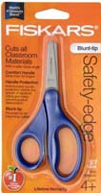
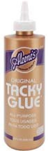
What I need to bring to my Pre-K 5’s class...

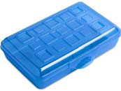
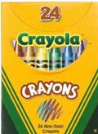
Please bring the following items to Parent Orientation. Please do not substitute brands.
- 6x9 in pencil box*
- Fiskars Blunt Tip Scissors*
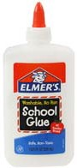
- 2—24 count boxes of Crayola Crayons*
- 2 Packages Crayola Broadline Washable Markers— 10 Classic Colors*
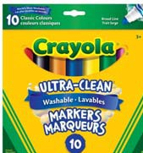
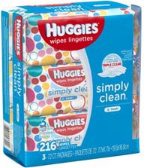
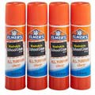
- 8 Large (22g) Elmer’s glue sticks*
- 4 oz bottle White Elmer’s School glue*
- 1 bottle (4oz) Aleen’s Tacky Glue*
- Marbled Composition Notebook*
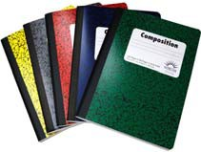
- 1 palette, 16 colors watercolors
- 1 Clorox Anywhere Spray (may be hard to find)
- 2—70ct or higher packages of Huggies baby wipes
- 1 box gallon size Ziploc bags
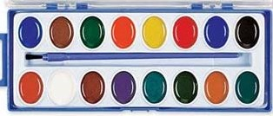
- 1 Change of clothes (please place in the Ziploc bag provided)

*Please label individual items with your child’s name or initials.

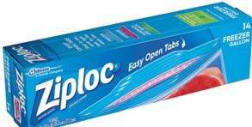
Please bring the following items to preschool each day…
- Peanut/Tree Nut free snack—labeled with child’s name and date
- Reﬁllable water bottle with a straw—labeled with child’s name
- My MVP tote bag
- My Parent/Teacher Communication folder
- Appropriate cold weather clothes for outside play (coat, hat, mittens, etc.)

