What I need to bring to my Pre-K 4’s
Class…

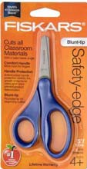
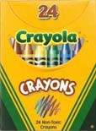
Please bring the following items to Parent Orientation. Please DO NOT label with your child’s name. Please do not substitute brands.
- 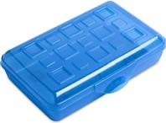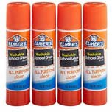6x9 in pencil box
- Fiskars Blunt Tip Scissors
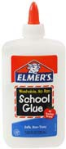
- 2—24 ct boxes Crayola Crayons
- 6 Large (22g) or 12 Small (6g) Elmer’s glue sticks
- 4 oz bottle White Elmer’s School glue
- 2 Packages Crayola Broadline Washable Markers—Classic Colors
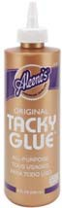
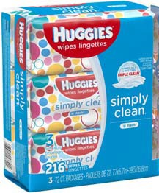
- 1 bottle (4oz) Aleen’s Tacky Glue
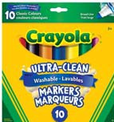
- 1 palette, 16 colors watercolor
- 2—70ct or higher packages of Huggies baby wipes
- 1 Clorox Anywhere Spray (may be hard to find)
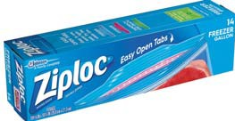
- 1 box quart size Ziploc bags
- 1 Change of clothes (please place in the Ziploc bag provided)

Please bring the following items to preschool each day… 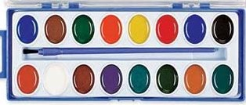
  - Peanut/Tree Nut free snack—labeled with child’s name and date
  - Reﬁllable water bottle with a straw – labeled with child’s name
  - My MVP tote bag
  - My Parent/Teacher Communication folder
  - Appropriate cold weather clothes for outside play (coat, hat, mittens, etc.)

