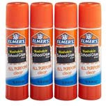
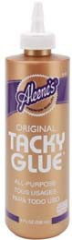
What I need to bring to my 3-year-old preschool class...

Please bring the following items to Parent Orientation. Please do not substitute brands.
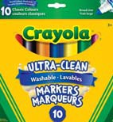
- 3 Large (22g) Elmer’s glue sticks
- 1 bottle (4oz) Aleen’s Tacky Glue
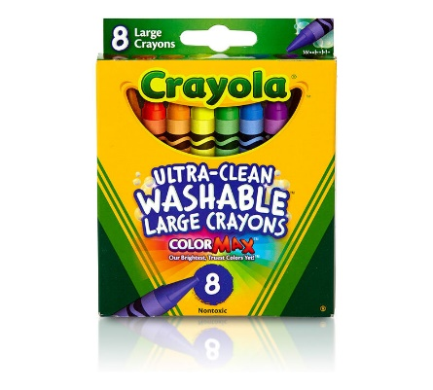
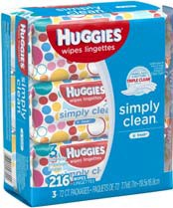
- 1 Package Crayola Broadline Washable Markers— Classic Colors
- 1 box—8 count LARGE (not jumbo) Crayola crayons
- 1 palette, 16 colors watercolors
- 1 Clorox Anywhere Spray (may be hard to find)
- 3 70ct or higher packages of Huggies baby wipes
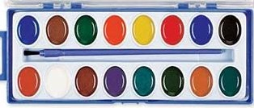
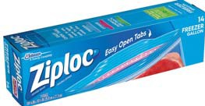
- 1 box gallon size Ziploc bags
- 1 Change of clothes (please place in the Ziploc bag provided)

Please bring the following items to preschool each day…
- Peanut/Tree Nut free snack—labeled with child’s name and date
- Reﬁllable water bottle with a straw – labeled with child’s name
- My MVP tote bag
- My Parent/Teacher Communication folder
- Appropriate cold weather clothes for outside play (coat, hat, mittens, etc.)

