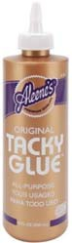
What I need to bring to my Toddler’s preschool class...

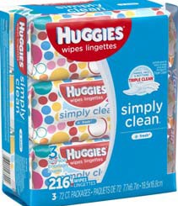
Please bring the following items to Parent Orientation…
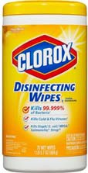
- 1 4 oz bottle Aleen’s Tacky Glue
- 3 70ct or higher packages of Huggies baby wipes
- 1 Container of Clorox Disinfecting Wipes
- 1 Clorox Anywhere Spray (may be hard to find)
- 1 box gallon size Ziploc bags
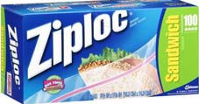
- 1 Change of clothes (please place in the Ziploc bag provided, include a pair of shoes and socks)
- 1 package of diapers or pull ups (if still potty training)

Please bring the following items to preschool each day…
  - Peanut/Tree Nut free snack—labeled with child’s name and date
  - Reﬁllable water bottle with a straw—labeled with child’s name
  - My MVP tote bag—labeled with child’s name
  - My Parent/Teacher Communication folder
  - Appropriate cold weather clothes for outside play (coat, hat, mittens, etc.)

